

BLUEPRINT FOR A SUSTAINABLE PLANET
Roy Mahoff – Stefan Schlau – Atrium Design
June 15, 2011

Foreword

Our global footprint now exceeds the world’s capacity to
regenerate by about 30 per cent. If our demands on the planet
continue at the same rate, by the mid-2030s we will need the
equivalent of two planets to maintain our lifestyles.
2008 Living Planet Report – World Wildlife Fund

The simple fact is every year greenhouse gas emissions and temperatures are rising, the world is becoming less sustainable, and the oceans and seas are rising, and no blueprint exists to reverse these ever accelerating events.

Just ten years ago if you said, “Sustainable Societies” few would know what you are referring to! Today, though we have the, “International Year of Sustainable Energy for All”, few would still do not know what this signifies or that climate change and global warming, fossil fuels and atomic energy are threats to all life on Earth!

To my knowledge there are no, “Sustainable Societies”, on our planet other than possibly a few hand to mouth tribes that are so isolated, therefore independent, that they continue to exist because they know how to sustain themselves with what they find already available in nature. We can do the same!

With the emphasis on “Global warming and Climate Change”, billions of dollars are being spent for renewables to wean us off fossil fuel with insignificant results and without truly introducing sustainability into the equation.

Solar, wind, hydro and biomass have made substantial advances toward renewable energy. Algae have been researched as the best alternative renewable fuel for the future, however to refine algae into biofuel is expensive and kept off the market until it can compete with fossil fuel.

The “Blueprint for a Sustainable Planet”, plan is for the planets 7 billion beings and rising, to use what nature has always provided to bio-process waste into clean energy, clean water, fertile land, and abundant food, while developing open source education.

The Universal Hexagonal Photobioreactor (UHPBR)

“Universal Hexagonal Photobioreactor, and component parts are registered under “Creative Commons – Open Source”. Licenses are available -roymahoff@gmail,com

“Increasingly, conventional bio-fuel crops are competing with food production for arable land. Closed algal bioreactors offer a promising alternative route for biomass feedstock production for bio-methane. Using these systems, micro-algae can be grown in large amounts (150-300 tons per ha per year) using closed bioreactor systems (lower yields are obtained with open pond systems). This quantity of biomass can theoretically yield 200,000-400,000 m of methane per ha per year.” Solar Biofuels consortium”

The Universal Photobioreactor UHPBR can be made of clear extruded polymer/biopolymers, in this case polycarbonates (PC).

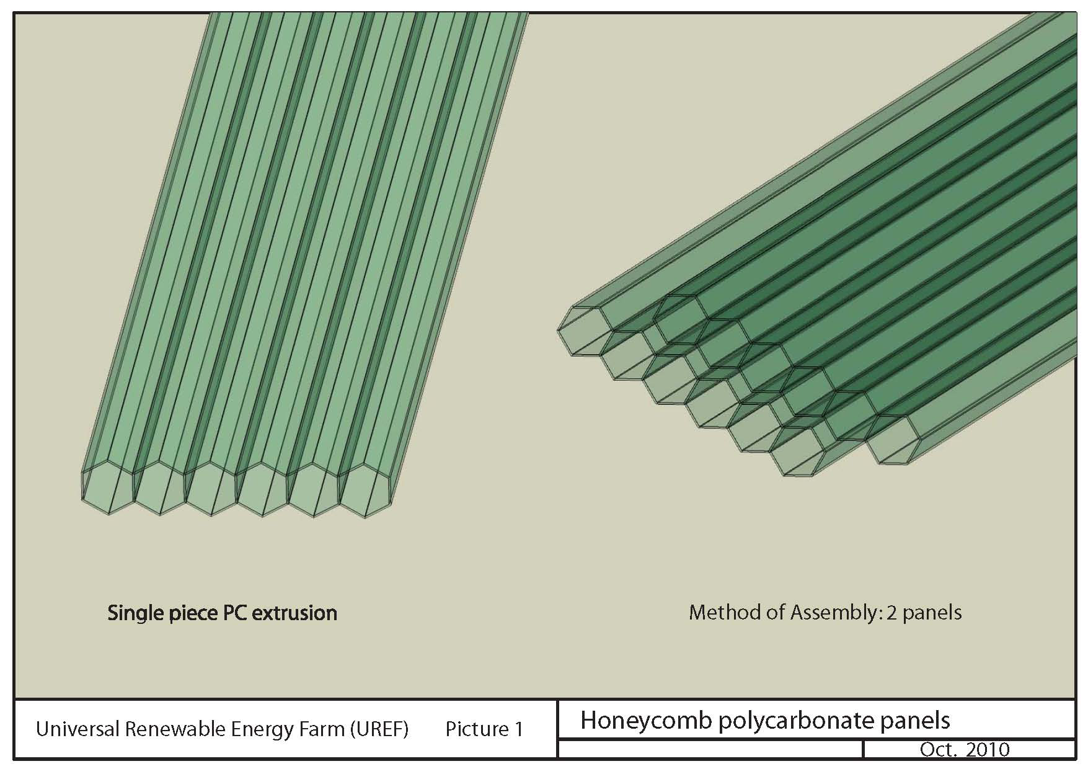

The PBR can scale to any length using rubber splicers pressed into opposing hex ends


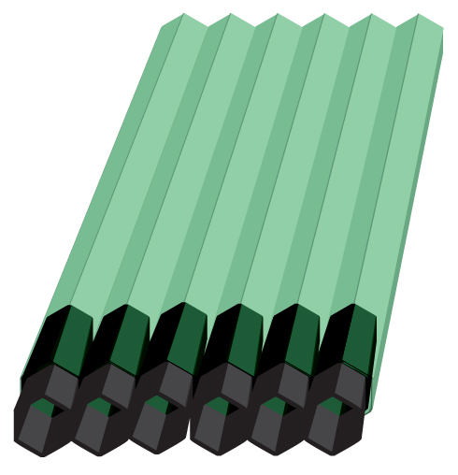

These PBR snap together to make a Honeycomb of PBR panels.

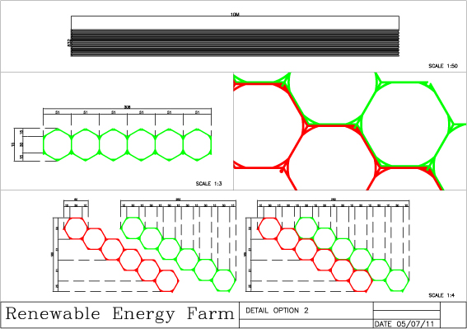

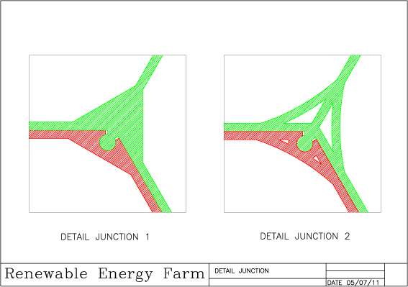
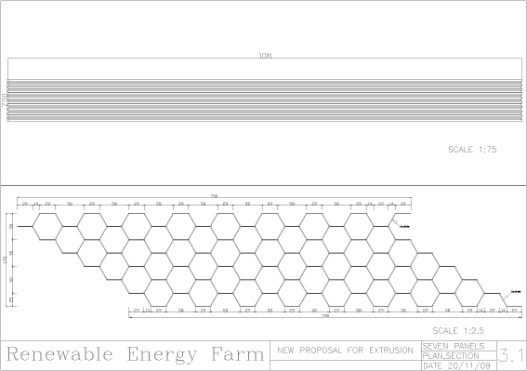

Other components such as “Universal End Plugs” (UEP) like in the drawing below serve as a UHPBR, using sun, water/ waste water/saltwater and a CO2 source so the reactor can grow micro-organisms, such as many strains of algae, that will provide us with a clean, cornucopia more sustainable future!
The PBR Panels are pressed into the rubber molded end plug encasement to form a watertight seal and join the layers of PBR panels.

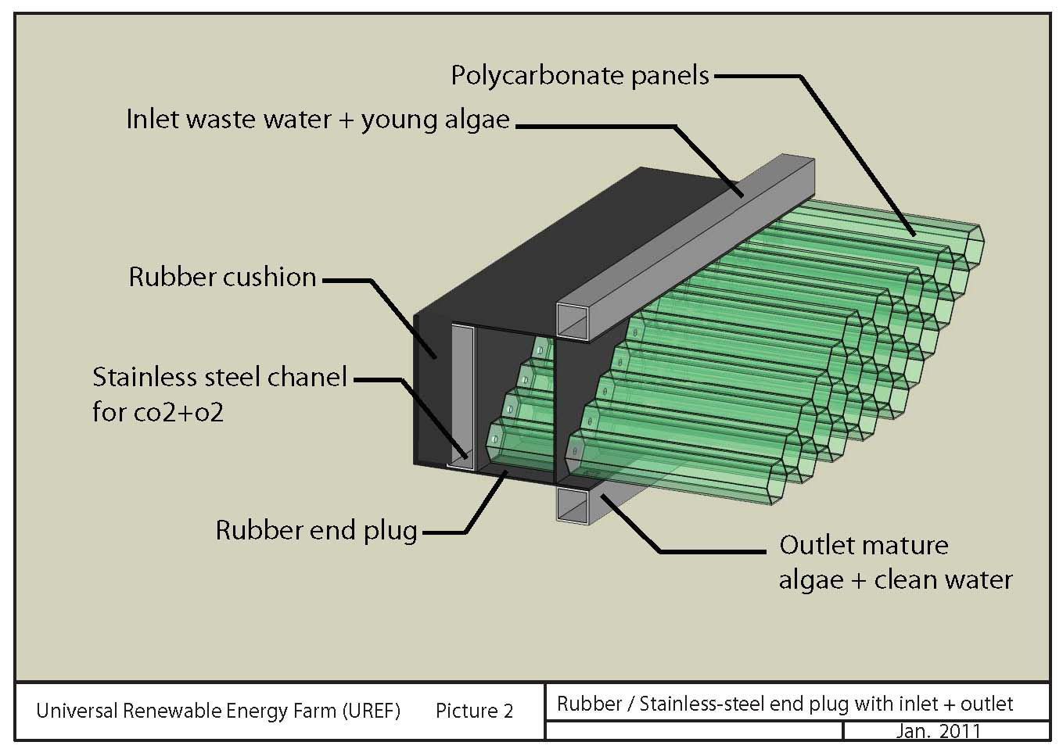
A small, 1cm pencil sized tube is also molded into each rubber plug from the bottom end of the plug through to the top end of the plug. These tube holes allow CO2 to enter the lower ends of each PBR and O2 to exit to exit the top ends.

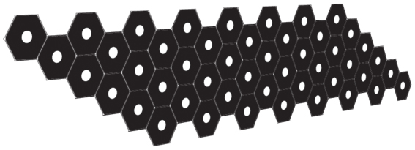

A rubber mat with Moon shaped valve slits corresponding to the center of each tube hole is adhered to the rectangular SS/PC rectangular CO2/O2 inlet/outlet with valves opening under CO2/ O2 upward allowing CO2 to bubble into all PBR channels and O2 to flow out the tops of the channels under pressure or possibly with a low pressure vacuum pump. When ever pressure drops the valve from pressure above close and seal (like a heart valve).

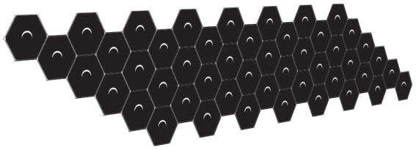

The rectangular SS/PC CO2 entry/O2 exit channel width and length corresponds with the moon mats width and length and is 4 cm deep. 1cm holes conform exactly with the 1cm wide moon slits as the mat is adhered to the rectangular channel (up to 11.5 meters in length).

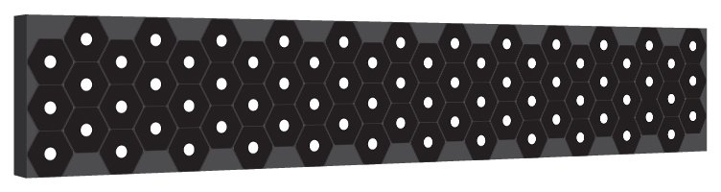

Square-12cm x 12cm ID and 11cm x 11cm OD Channels of SS/PC have universal 4cm circular hole cutouts on one side to correspond with the upper and lower circular cutouts on the top and bottom of each PBR panel. As shown in the UEP mold design there are rubber mats that extend the width of the UEP, these also have the same corresponding circular cutouts.
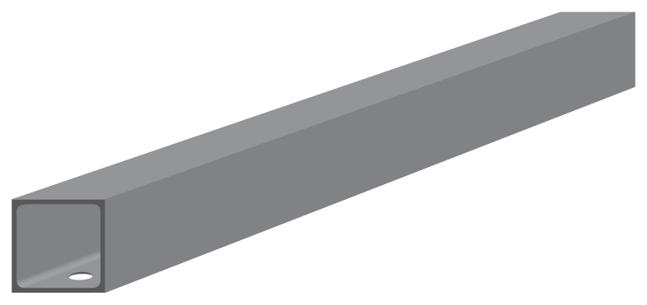

Left and right end plugs for the upper and lower UEP ends are off the shelf PVC fittings molded into plugs for both the rectangular and square channels.

Standard PVC pipe can serve to splice UEPs together so there is no separation between one UEP, left and right. Also at either end of the total width of the UPBR
Standard PVC fittings can be used to connect up with valves hoses and other equipment as per application.
Cleaning the PBR channels is accomplished with snub nosed hexagonal cleaner sponges 7cm long and 5.5cm in diameter with spiral ridges allowing the sponge to twist as it travels at the same flow rate as the algae and to give it the flexibility needed to compress and make the turn through the joining internal ports.


Like an ammo belt as in the drawing below 6cm long cleaner sponges are loaded into 3cm ID PVS pipe 6cm with slits on both sides of the top end for a nylon ribbon and round tube plastic spacers so the tubes loaded with cleaner sponges exactly line up with the entry ports of each PBR. On either end of the square SS/PC channel is a 9cm ID “Y” fitting with the angled portion of the “Y” facing outward and upward and fitted with a screw plug. With valves off and plugs removed the loaded sponge ammo belt is pulled through with the nylon ribbon passing through an eyelet and making a loop with the ends of the nylon ribbon tied together. Once the ammo belt is pulled through into position the bottom valve is opened, the cleaner sponges are pulled into the each entry hex, the valve is closed and belt removed and plug caps. Sponges exit the bottom “Y” fitting for cleaning and reinstalling in the ammo belt.

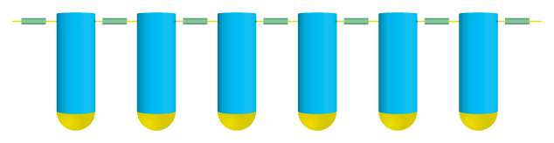

A heavy duty universal steel U channel 24cm wide 24cm high encapsulates the bottom end of the UPBRs to be welded to support beams of whatever height or encapsulated in concrete as per design and application of the HPBR.

This is a continuous honeycomb arch for algae to flow up and down each of the 6 - 5cm channels of each of each PBR while forming a self-supporting green house structure.

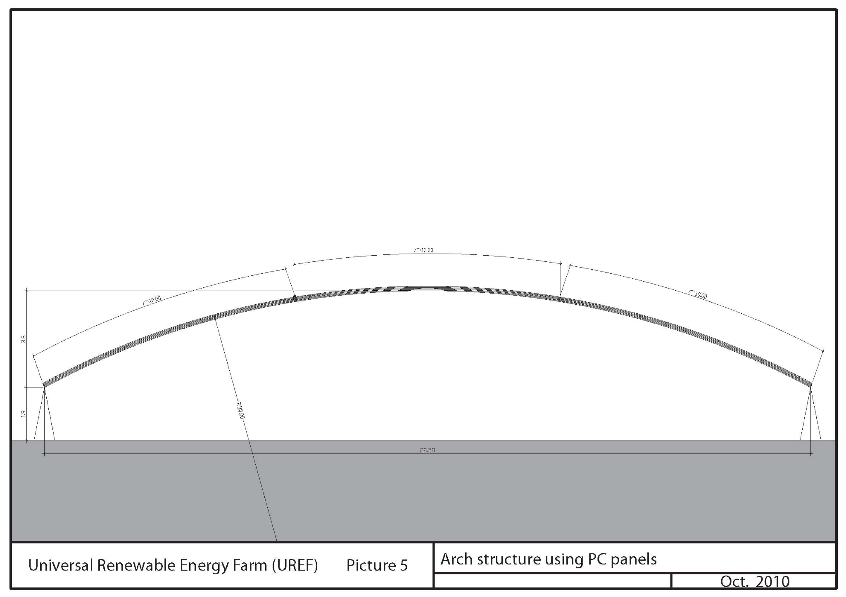

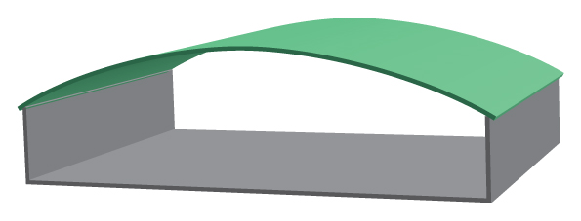

Introducing the “Universal Renewable Energy Farm” UREF

- The algae UREFs 17.4 cm depth optimizes light transmission and can be tilted at any angle above the horizontal longitudinally to make best use of the solar day regardless of latitude.

- A UREF can take many forms, such as, the roof of a greenhouse for growing organic foods, housing a dairy, pigs fowl, fish ponds, a municipality, school, warehouse, etc. A UREF can be atop, hotels, parking lots, on the sunny sides of buildings, skyscrapers, floating on lakes and rivers, cleaning up canals, in deserts, cleaning up nuclear waste sites!

- A UREF needs no agricultural land or clean water source. Municipal water brackish and salt water will be cleaned of nutrients and toxins by the UREF and recycled as clean agricultural water, recycled to produce more algae or go back clean to the sea.

- Whether hot or cold exteriors, interiors can be controlled without expensive air conditioning with the insulating value of the PBRs. In cold climates CHP heat can warm the algae inlet tank to the best temperature for algae growth and routed into all PBRs and balance interiors for healthy growth of organic feed/fuel as a natural environment for humans/animal/fowl/fish.

- The interior of a UREF green house can serve many uses such as organic farms including aeroponic and hydroponic systems. Farm animals, fowl, fish can thrive in this environment feeding on algae supplements and providing organic foods while recycling their waste into the UREF to provide more organic food/feed and energy.

- In the case of algae production, the algae produced can be used for high grade food supplements for humans, farm animals, poultry, fish, shell fish, shrimp, cosmetics, medicine, neutriceuticals, as well clean water, oxygen and fertilizer for soil amendment.

- Various species of algae can produce highly profitable food supplements, cosmetics, neutricuticals, and medicines.

- High lipid content algae can be refined into transportation biofuels however at this time it may prove more cost effective to produce methane for distributed energy and have the ability to produce methanol as well.

- Algae, anaerobically digested with paper and other digestible organic matter can produce large quantities of methane gas (CH4) to be used as natural gas for heating, cooking, and low emission electric generation, preferably using a 90% + efficient methane fuel cell for combined heat and power (CHP) to Produce local distributed power at a competitive or lower cost than utility power today.

- Anaerobic digestion of algae also produces high-grade sterile organic fertilizer for soil amendments producing healthy organic food stocks and organic waste for further bio digestion for energy and fertilizer.

- 50/50 algae and paper digestion doubles methane production.

- Incorporating anaerobic digesters can also clean up municipal organic waste/industrial waste solids along with algae to provide clean energy and high-grade organic soil amendments for food production including recycling fertilizer as feed stock for further algae production.

- Rainwater collection and is easily integrated into the UREF.

- Providing appropriate shading enhances algae growth. The capability now exists to print photovoltaic on clear UV proof Mylar type material. Printing 5cm PV, leaving a 5cm clear strip then PV strip and so on, the clear Mylar type material plus providing a mechanism for the Mylar sheets to overlay the UREF panels without touching and have the ability to raise and lower the PV sheets to control heat buildup as well move the sheets left to right 5cm at the correct automated cycle would provide algae shading and algae growth as well provide large amounts PV power and UV protection for the PC panels giving them a longer life span.

- New devises are becoming available that can use rising heat escaping the top of the UREF to turn this heat into electric energy for further power distribution.

- Algae can grow with strontium 90 and iodine radioactive seawater. In the case of Japans recent nuclear meltdown and not only the sea but also the land as well around the affected nuclear reactors and its affects on all living things where high levels of radiation can continue to last up to 100 years is devastating. Taking irradiated sea and ground water to grow algae to mix anaerobically with radiated vegetation and other organics produces methane and clean electrical energy. The fertilizer is still somewhat irradiated but still allows plants to grow that can tolerate the radiation levels. Each cycle reduces the radiation while producing clean power. Instead of a 100 year cleanup maybe 20 years, maybe less.

- Growing certain species of algae in a UREF can nullify nuclear waste from nuclear power plants all over the world while providing energy and a safe nuclear waste free world.

Cost & Return

First put aside the cost of wars providing no benefit to mankind for what ever reason whether political, religious, geographical, for minerals, water, land or food rights, only for richer never for poorer also include extinction, starvation, devastation, disease, tsunamis, nuclear melt downs, floods, earthquakes, volcanoes, water shortage, polluting landfills, financial and other problematic cataclysmic probabilities causing enormous loss, loss of life and the future well being of all.

Now, look at UREFs located on low or no cost non agricultural land and water not suitable for habitation, tops of buildings, over parking lots lowers capital cost upfront. UREF’s provide food/feed, and energy, shelter for less cost and greater profits than importing polluting fossil fuel and hydro energy. UREFs clean up wastewater by growing algae and anaerobically digest organic waste into energy and chemical free fertilizer locally, and provide low cost energy, organic feed and food while cleaning up costly community waste and landfills. Mining landfills rather that filling them for their valuable recyclable organic and inorganic materials provide profits for clean healthy secure communities. Bottom line, waste makes no longer is a cost but an added profit to the community! Carbon credits also add to profitability.

Along with UREFs, wind, solar, hydro can provide cheap distributed local power to the community and natural gas. Transport can be powered as well by low polluting natural gas, and non-polluting electricity for inexpensive new/converted EV motorbikes, cars, trucks and boats.

With low interest bank loans the return on investment will be well below 10 years and likely 5 years by integrating digesters, solar, organic feed/food, fuel cells, EV transportation, as well as newer technologies to provide for an even faster payback.

CDM funded UREFs provide capital needed to fund UREFs to earn carbon credit. UREF communities using their own local renewable resources can sustain themselves providing a 20% plus payback at no cost plus greater health, security and prosperity now and for all future generations.

“Waste, a free sustainable renewable resource to replace fossil fuel and empty landfills, reduce pathogens, clean the air and water, provide energy locally costing less than imports and provide greater prosperity and health for all communities world-wide to enjoy a sustainable future."

Summary

Our 11-1/2 meter long PBR has a flow length of 69 meters and with connecting splicers the PBRs can scale to any desired length for optimal growth and harvest of a desired species of microorganism in minimum time.

Optimizing length provides a constant regulated flow rate to minimize harvest time using electronically controlled entry exit valves to control flow based on light transmission and algae density. CO2 input is also controlled and oxygen is automatically released.

- Every village, town, municipality, city with UREFs can begin to mine their landfills, convert trucks and tankers to EV to deliver fertilizer and recondition fields and forests to once more provide beauty and bounty and habitats for otherwise endangered species.

- Looking to the near future with the advent of zero emission electric transportation UREFs will not only help phase out fossil fuels but also expensive low yield, polluting biofuel from corn, soy, sugar, and palm oil that belong on the dinner table, not in the gas tank.
            Used vegetable oil is easily recycled and refined into biodiesel, even jet fuel.

- A UREF can become the central utility for world-wide communities to clean up all waste water and digestible organic waste while producing energy and fertilizer from the waste and use interior space to separate other waste to recycle for other means rather than going to landfills.

- A UREF can provide the means to clean up nuclear waste.

- Algae very important capability is its ability to sequester tons of CO2, and Methane (21 times more greenhouse gas than CO2) becoming carbon negative, while producing 100% more pure oxygen than it needs to grow.

- With local decentralized UREF food and energy production come, sustainable jobs, prosperity, education, healthy clean environment, zero pollution, security with balanced trade stemming the exodus and helping family communities build close ties without further threat of centralized outside control.

- Combining UREFs, wind, solar, hydro electric, new technologies, organic food/feed production grown locally can help to reverse climate change, global warming, famine, draught, and poverty. Community’s worldwide can enjoy renewable & sustainable security, and make hunger, poverty, oil wars and large military operations to secure natural resources a thing of the past.

Instead of conquering nature, we need to let nature be our ally & bond & create a truly “Sustainable World!” We all win acting swiftly to modify the “Blueprint”, keeping in sight the goal of renewable & sustainable secure global societies forever &, for each OTHER!

"Let’s Clean-Up & Grow"

Contact Information:

Roy Mahoff – Sustainable Innovation- Affiliation Atrium Design – mob -+ 66 (0) 82-2425601/ Thai + 66 (0) 83-779-6771- roymahoff@gmail.com

Stefan Schlau, Principal Atrium Design Co. ltd. – tel - +66 (0)2-655-8512 - fax - +66 (0)2 655-8513 – mob -+66 (0)8 7154-1070
Polo House, Soi Polo, Wireless Rd. Bangkok, Thailand 1033atriumss@gmail.com – www.atriumss.com

Universal Renewable Energy Farm by Roy Mahoff/Stefan Schlau is licensed under a Creative Commons Attribution-NonCommercial-ShareAlike 3.0 Unported License. Based on a work at roymahoff@gmail.com. Permissions beyond the scope of this license may be available at roymahoff@gmail.com

